USER MANUAL

Automated Code Compliance Check

Document Control

Revision History

Date | Author | Version | Change Summary
23/05/2018 | Antara Roy Chowdhury | 1.0 | Initial Version
27/07/2018 | Brati S Ghosh | 1.1 | Added section on execution using JDeveloper

Contributors
Contributor | Role | Position

Reviewers
Name | Role | Position | Document Status | Date Reviewed | Comments Incorporated
Brati S Ghosh |  | Delivery Lead

Contents
Document Control 2
Revision History 2
Contributors 2
Reviewers 2
Introduction 1
Scope for this Document 1
Glossary 1
Tool Features and Usages 2
Technology used 2
Tool features 2
List of Review Rules in present tool 2
Tool Usage 3
Executing CCI from JDeveloper 8
Open and Closed Issues 10
Open Issues 10
Closed Issues 10
To update this table of contents, click on it and press F9.
TIP: To jump directly to a page, click on the page number.

Word will generate the above table automatically if you add captions to your diagrams using the menu command Insert->Caption. To update this table, click on it and press F9.

Introduction

The purpose of this user manual document is to describe the functionality of the Code Compliance Inspector tool which comes as an OOB extension to Jdeveloper 12C.

Scope for this Document
The scope of this document is to provide guidelines on how to use the tool. It does not describe any technical design.

Glossary
Term | Definition

Tool Features and Usages
LDescribe all the details of every integration service that has been described in section 5. Replenishment Order - OMS To Data Hub Design

Technology used
Code compliance inspector is an extension which is available as a plugin to Jdeveloper 12C and uses the following technologies:
XML, HTML, Java

Tool features
- This tool is to be used identify if the SOA or OSB code is developed as per the prescribed guidelines or conventions.
- User can use this tool without installing Jdeveloper as this extension can work independently.
- The user must install Java in his/her machine. This tool is tested to work on Java 8
- The user must set the JAVA_HOME environment variable under system variables.
- The reports can be generated in both XML and HTML format.

List of Review Rules in present tool
The tool has been developed to execute the following checks. –

SOA:
- Remote Fault Catch block should exist in Fault Handler
- Binding Fault Catch block should exist in Fault Handler
- The Common IIP Error Handler Composite(IIPAsyncErrorHandler) has been invoked from the composite
- Default Names are changed in Reply Activities and following standard convention
- Default Names are changed in Receive Activities and following standard convention
- Default Names are changed in Scope Activities and following standard convention
- Default Names are changed in Invoke Activities and following standard convention
- Default Names are changed in Assign Activities and following standard convention
- The BamFlag preference variable is initialized to 'N'
- The Preference variable for the Expiration Time has to be assigned to 3600.
- Title for the composite has been set.
- Error Scope Exists in BPEL
- The Error Variable in the Switch activity of the Error Scope is assigned from the Error Handler Block.
- The audit level property is not set in the composite.xml
- No users are associated to the schema element in XSD.

OSB:

- Provide a Description to the Proxy Service with its functionality
- Provide a Description to the Business Service with its functionality
- Change the default Eclipse generated name for the Stage activity
- Change the default Eclipse generated name for Route Node.
- The variable name should start with V or v"
- Every Stage or Route Node or Pipeline should have an error handler
- There Should not be any XSLT Transformation Used in OSB
- There Should not be more than 2 Assign activities in a stage.

Tool Usage
- Go to the folder ComplianceInspector/bin
- 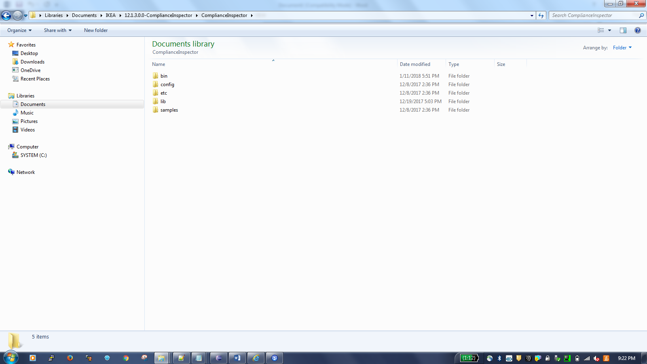
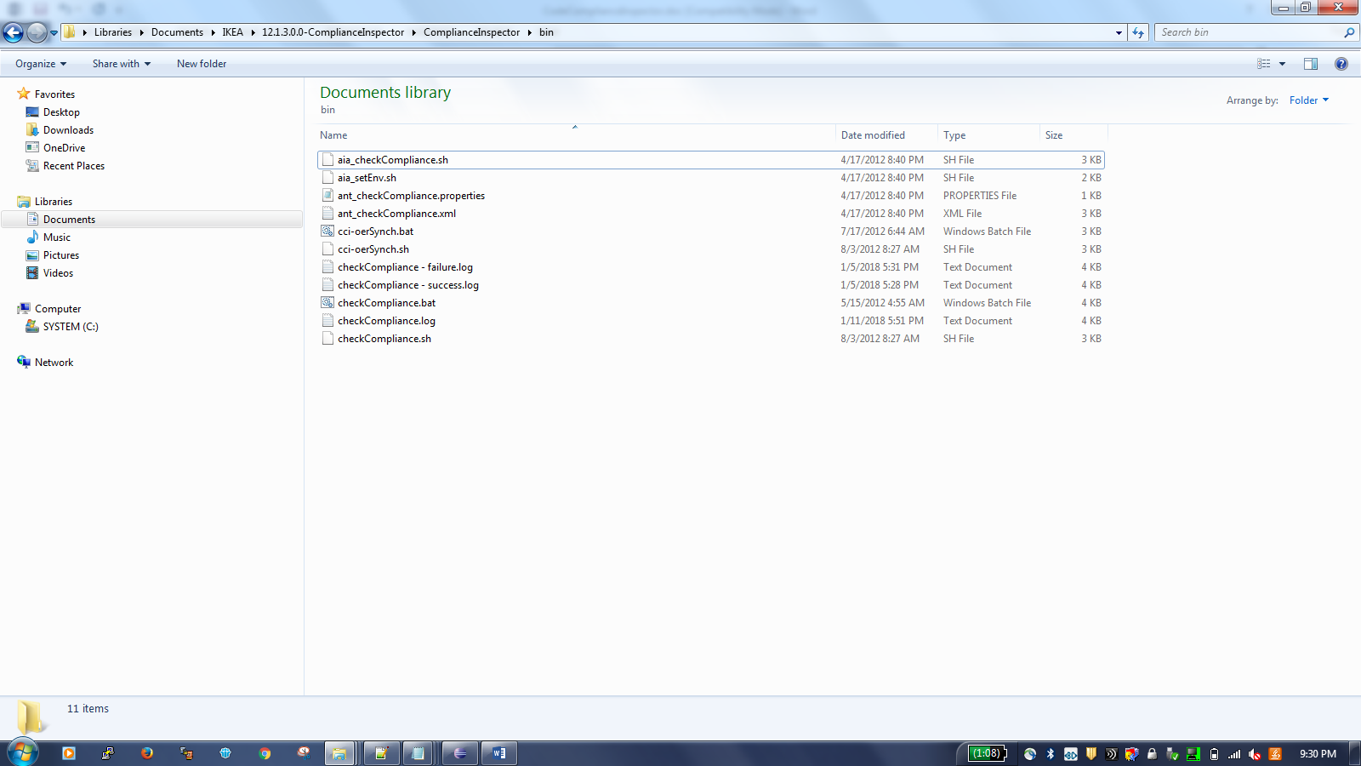

- Run the checkCompliance.bat file from command prompt using the below command.
checkCompliance.bat -inputDir inputDir -outputDir outputDir
Where
inputDir is the path of the parent folder containing the code to be reviewed.
outputDir is the directory in which you want the report to generate

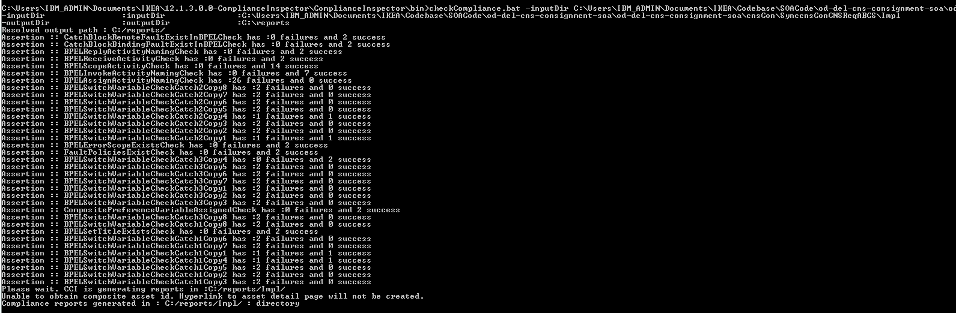

- An XML <<projectname>> _ComplianceReport.xml will get generated in the output directory along with an HTML report.
Final report Generation (XML):
- Run the below command to get the final result for CCI
checkCompliance.bat -inputDir <<outputDir/<projectname>> from the previous command >> -outputDir <<The directory in which you want the final report to generate>> -assertion AssertionSuccessTest_SOA or AssertionSuccessTest_OSB
- HTML format for the Compliance Report will get generated in the below location
<output directory>/<project name>/reports/ComplianceReportByPolicies.html

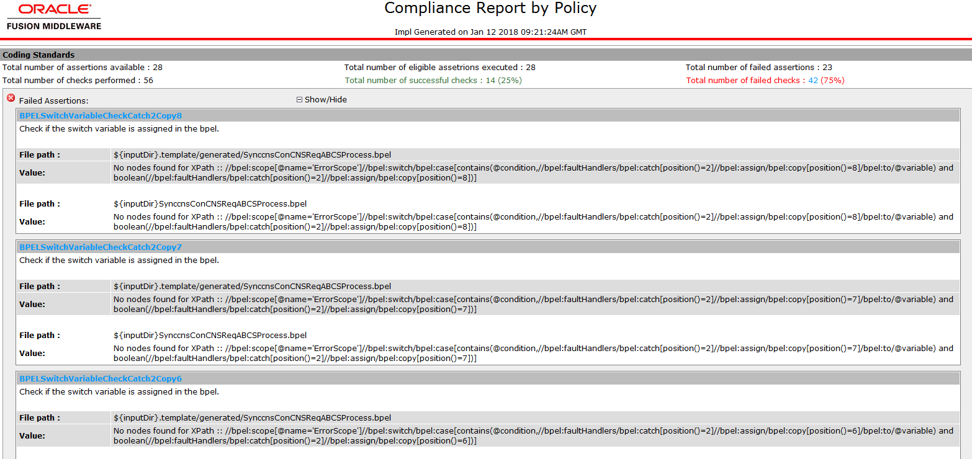

Compliance Report (HTML):
- There will be 2 reports generated here.

- The 2nd report is the summarized report for all the rules. This only shows the status of the rules against a project, i.e. the rules have passed or failed.

Summary of Checks

Rules which have failed

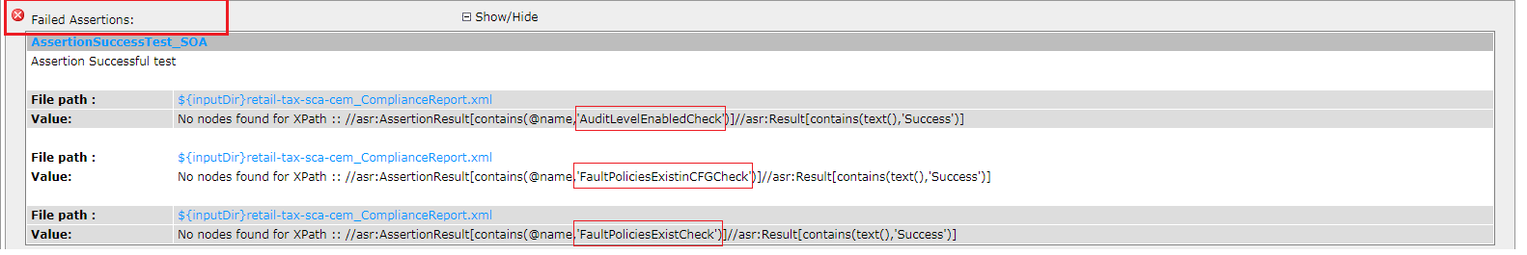

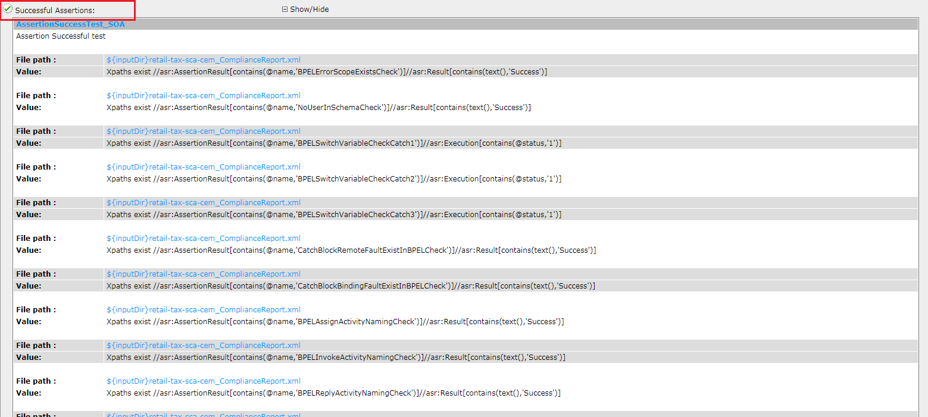
Checks which have successfully passed.

- The 1st report holds elaborate details and the exact location of files where the rules have failed.
The 2nd report (given above) shows the rules which have failed e.g. in this case there are 3 failed rules. Search for these rules in the 1st report to get the exact location of the failure. Below are the example screenshots

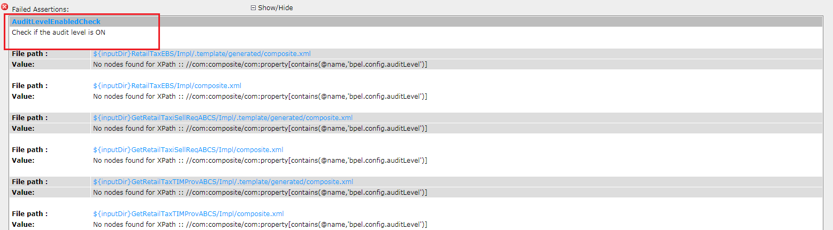

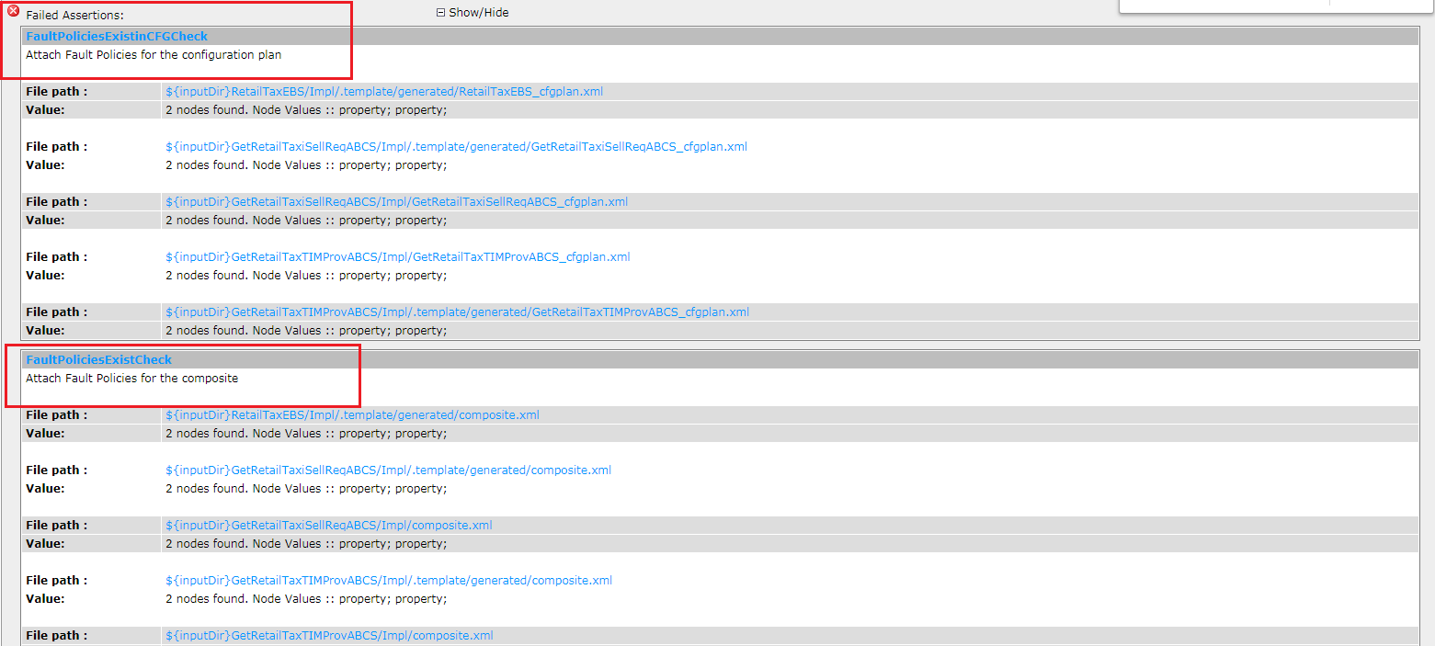

Executing CCI from JDeveloper

We can execute Code Compliance tool from JDeveloper. Following are the steps that can be used to do the same

Step 1 : Open JDeveloper and from the Tools menu select External Tools
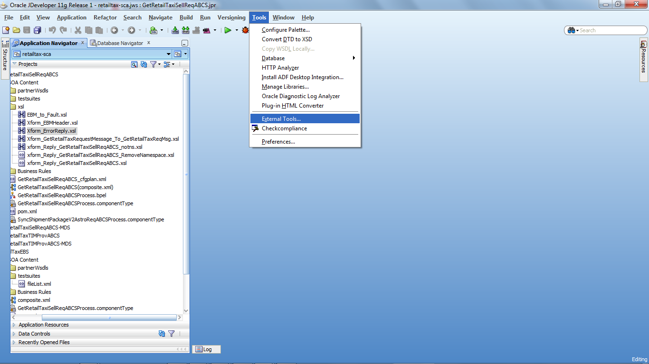

Step 2 : Select “External Program” from the Tool Type drop down

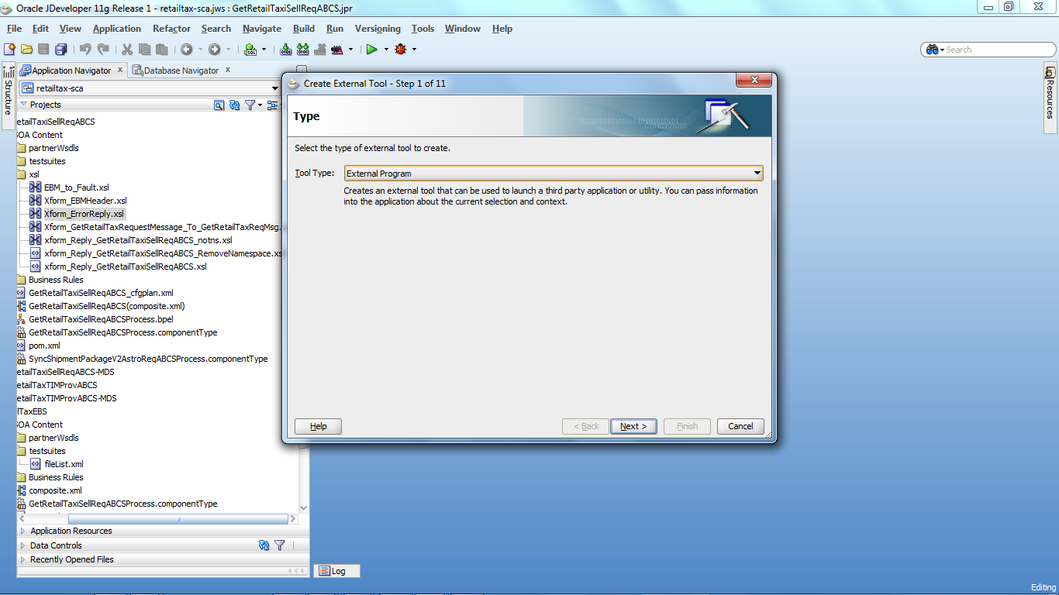

Step 3 : In the ensuing screen provide path of checkCompliance.bat in the ComplianceInspector\bin folder in the Program Executable tab. In the Argument tab provide the –inputDir and –OutDir parameter values

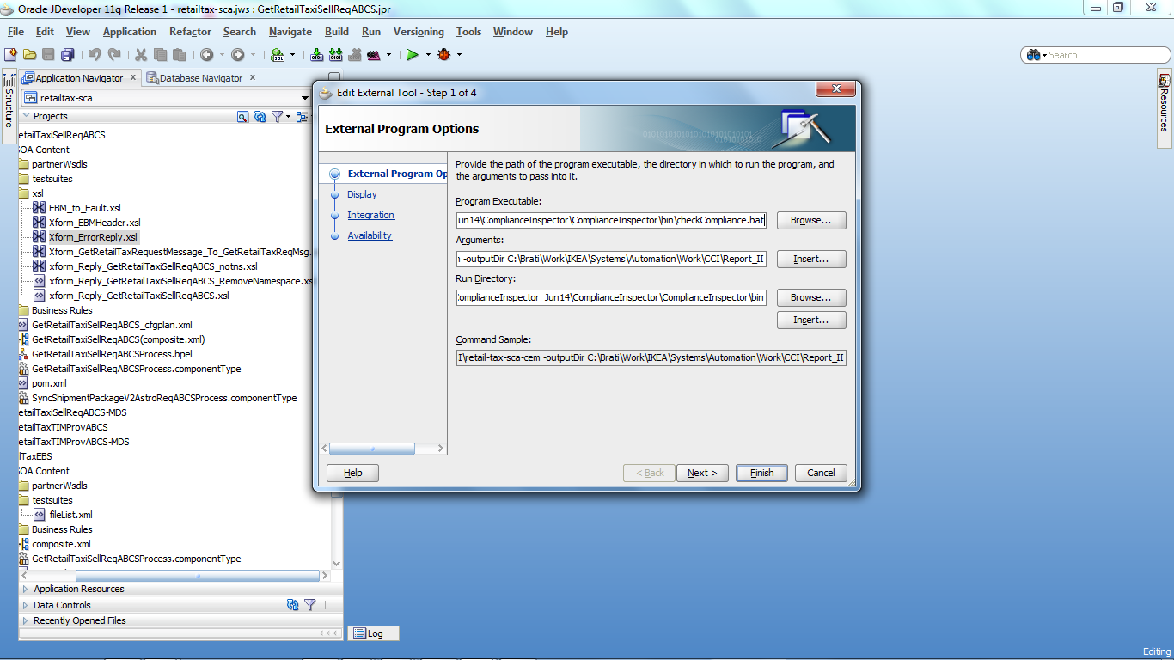

Open and Closed Issues
Enter new open issues in the Open Issues table below. Use the blank second row for a long explanation of the issue. When an issue is closed, select both rows then cut and paste the rows into the Closed Issues table. Then replace the Action and Target date cells with the description of the resolution and the date closed.
Always preserve the original issue number when transferring issues from Open to Closed.

Open Issues
            - We are still in the process of adding more assertions to ensure a detailed check on the coding standards.

Closed Issues
NA

Use this section to list specific business use cases that would substantiate this technical design. The use cases should be realistic business scenarios and not theoretical examples.

